Final Project Report
Inventory Management System

- Title : Inventory Management System Using Spring Boot and MongoDB

- Project Overview:
The Inventory Management System is a backend web application developed using Java (JDK 17), Spring Boot, and MongoDB. It provides a structured way to manage inventory records such as Products, Categories, Suppliers, and Warehouses through RESTful APIs.
The system demonstrates modern backend development practices including:
- API development with Spring Boot
- Database integration with MongoDB
- Layered architecture (Controller → Service → Repository → Database)
- Exception handling
- Validation
- API testing with Postman
- API documentation with Swagger/OpenAPI
- GitHub integration for version control and submission
“The project is designed to provide a simple, scalable, and efficient solution for inventory management.”

- Objectives:
• Build a backend inventory management system.
• Implement CRUD operations using REST APIs.
• Integrate MongoDB for data storage.
• Apply layered architecture principles.
• Handle exceptions gracefully.
• Validate inputs using Spring Boot validation.
• Test APIs with Postman.
• Document APIs with Swagger/OpenAPI.
• Submit project via GitHub repository.

- Tools and Technologies Used:
Tool / Technology | Version | Purpose
Java JDK | 17 | Programming language
Spring Boot | 3.5.15 | Backend framework
MongoDB | 6.x (local instance) | Database
VS Code | Latest | Development environment
Maven | Build tool | Dependency management
Postman | Latest | API testing
Swagger | 2.8.6 | API documentation
Lombok | Latest | Boilerplate code reduction
Git & GitHub | Latest | Version control & submission

- Concepts Implemented:
- Backend Development Concepts
- Spring Boot Starter Dependencies (spring-boot-starter-data-mongodb, spring-boot-starter-web, spring-boot-starter-validation).
- Layered Architecture → Controller, Service, Repository, Model.
- Dependency Injection for service and repository layers.
- Exception Handling → GlobalExceptionHandler, ResourceNotFoundException.
- Validation → Spring Boot validation annotations for input data.
- Lombok → Used for reducing boilerplate code (@Getter, @Setter, @NoArgsConstructor, etc.).
- Database Concepts
- MongoDB Collections → Categories, Products, Suppliers, Warehouses.
- Entity Relationships:
  - One Category → Many Products
  - One Warehouse → Many Products
  - One Supplier → Many Products
  - One Product → Multiple Suppliers
- API Development Concepts
- RESTful APIs for CRUD operations.
- Swagger/OpenAPI for auto-generated API documentation.
- Postman Testing for verifying endpoints.
- Project Management Concepts
- GitHub Repository → Project uploaded with .gitignore, README.md, and source code.
- Maven Build → Dependency management and project packaging.

- System Modules:
- Product Management → Add, View, Update, Delete Products
- Category Management → Manage Product Categories
- Supplier Management → Store and Manage Supplier Information
- Warehouse Management → Manage Warehouse Details and Product Storage

- REST APIs Implemented:
Product APIs
- POST /products → Create Product
- GET /products → Get All Products
- GET /products/{id} → Get Product by ID
- PUT /products/{id} → Update Product
- DELETE /products/{id} → Delete Product
Category APIs
- POST /categories
- GET /categories
- PUT /categories/{id}
- DELETE /categories/{id}
Supplier APIs
- POST /suppliers
- GET /suppliers
- PUT /suppliers/{id}
- DELETE /suppliers/{id}
Warehouse APIs
- POST /warehouses
- GET /warehouses
- PUT /warehouses/{id}
- DELETE /warehouses/{id}

- Output Screenshots:

1.Project Structure
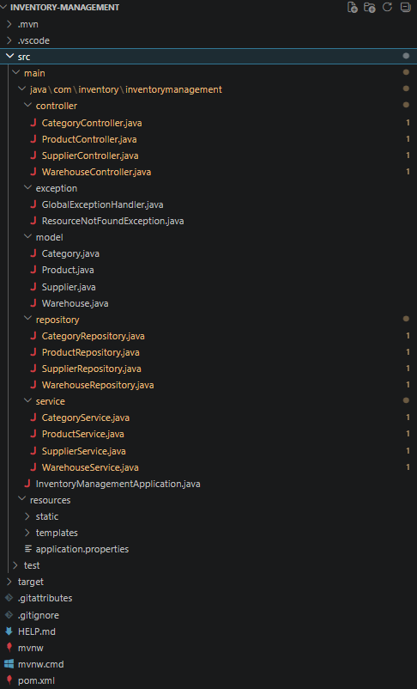

2. application.properties
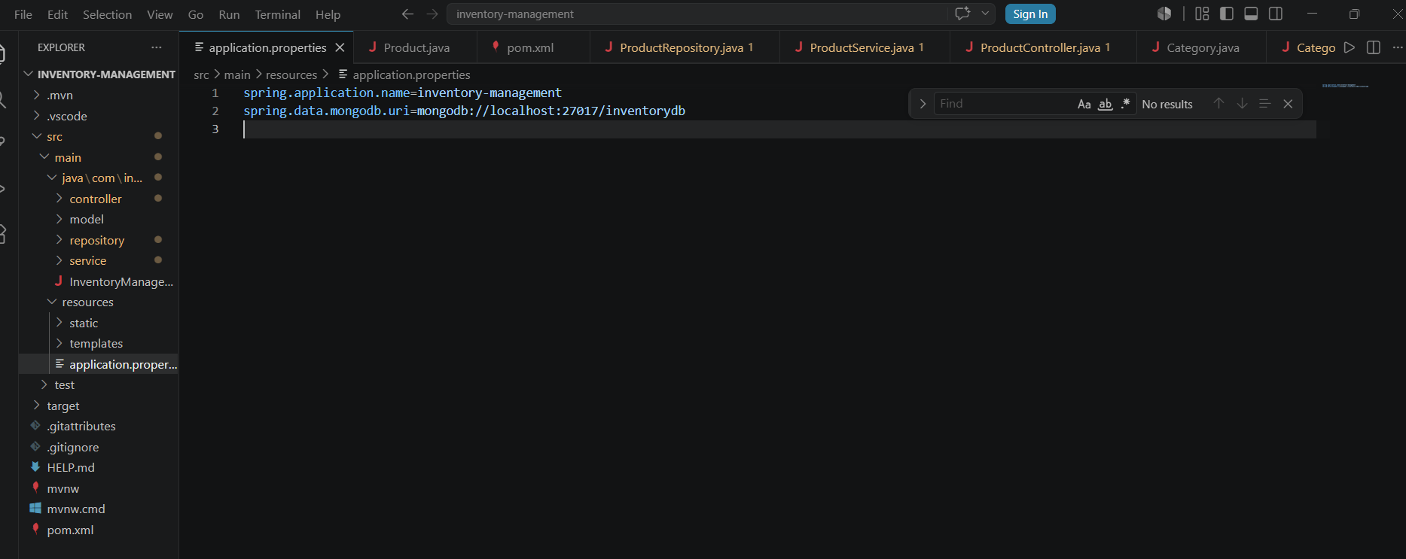
showing MongoDB connection string.

3. Spring Boot console log
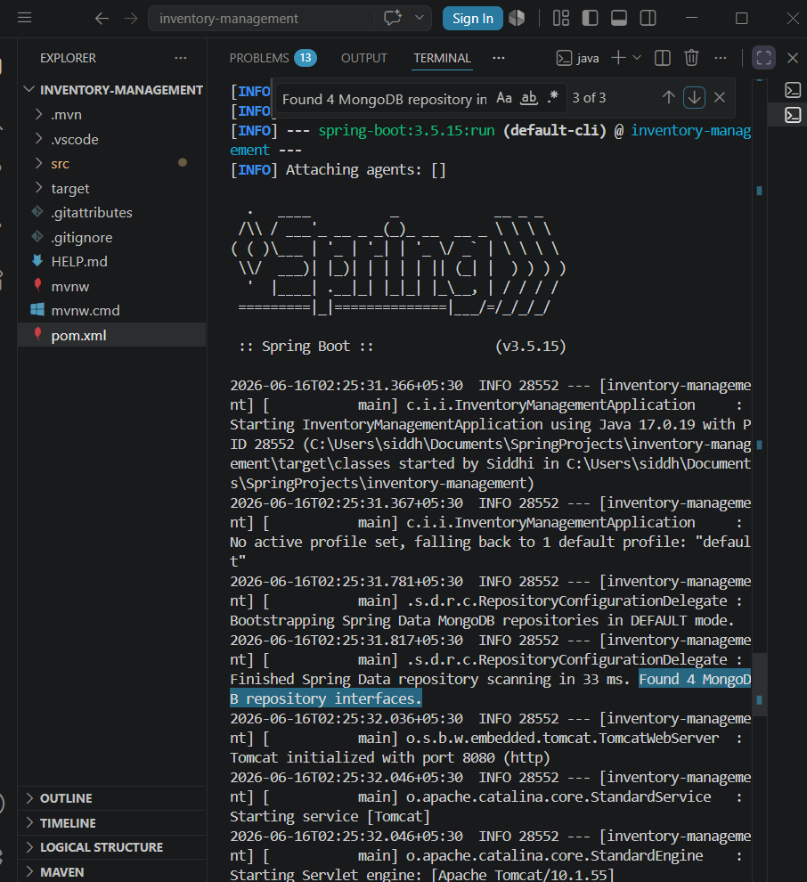

showing successful startup, MongoDB repositories found, Tomcat running on port 8080.

4. Database Evidence (MongoDB Compass)

Products Collection - Relationship Mapping
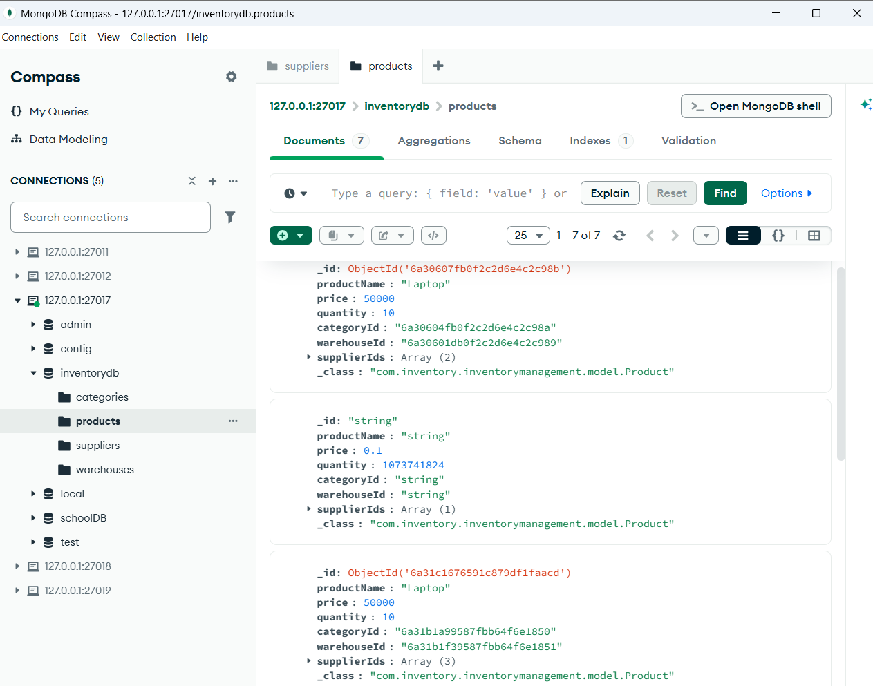

Categories Collection
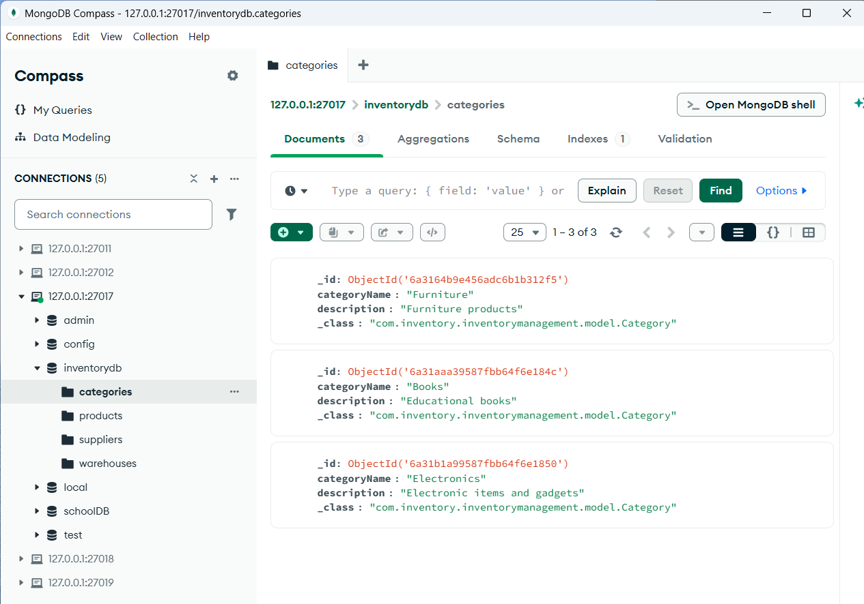
- Suppliers Collection
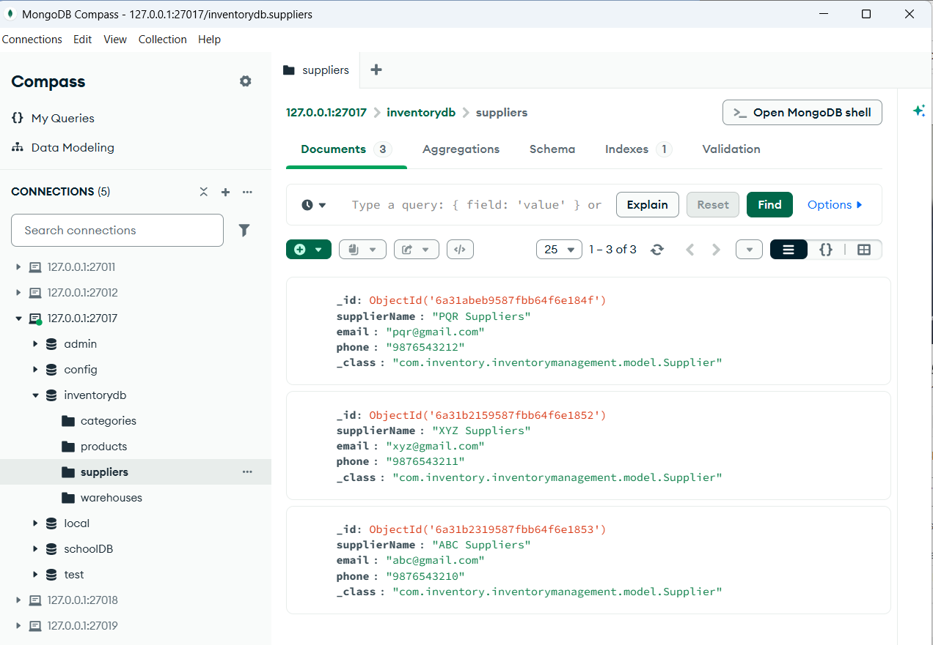
- Warehouses Collection
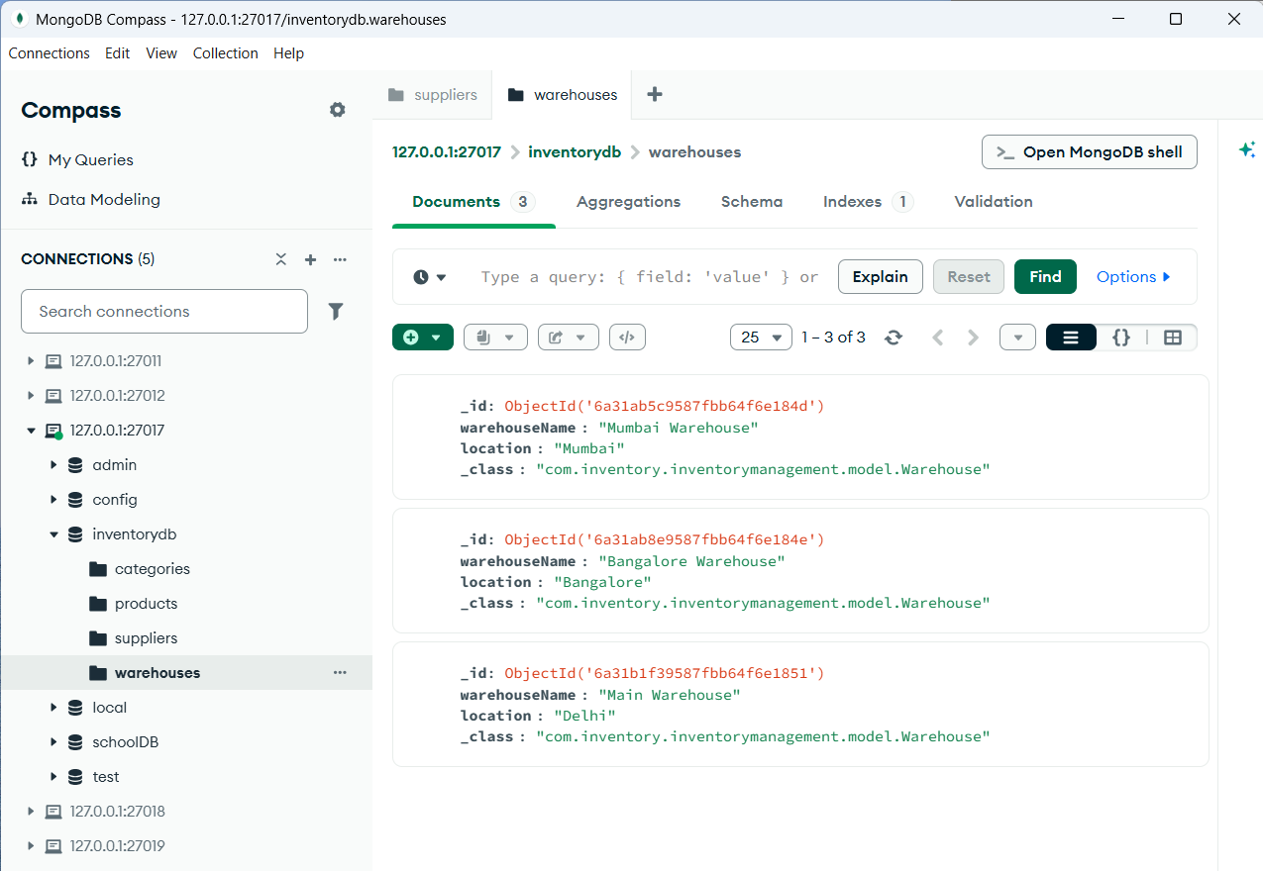

- Postman API TESTING
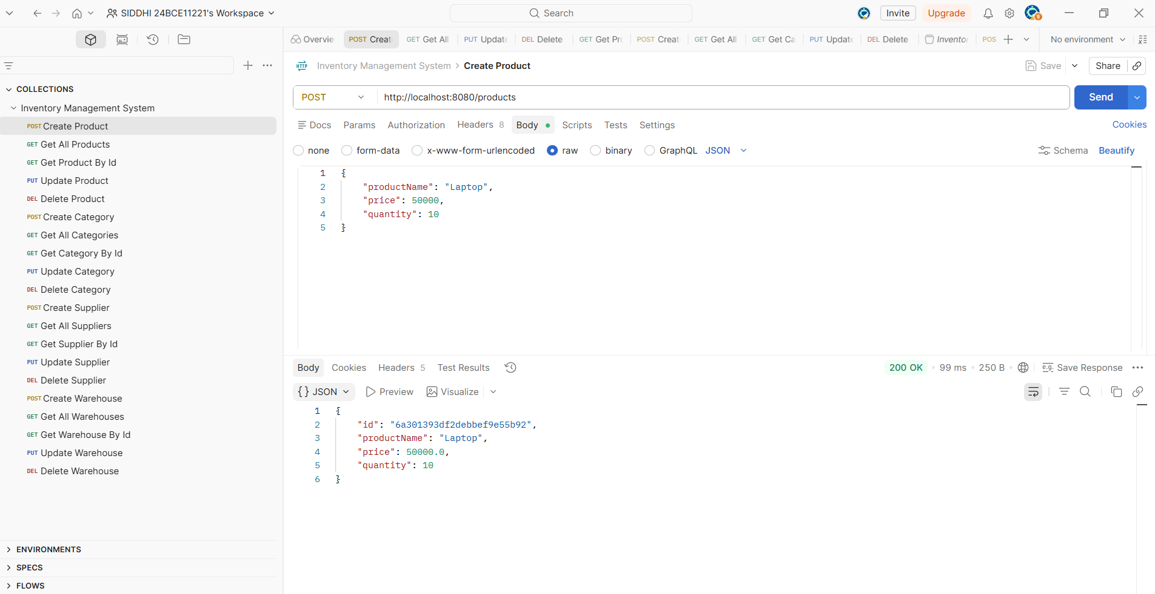
It demonstrates the Create Product operation, where a new product named Laptop with a price of ₹35,000 and quantity 10 is successfully added.

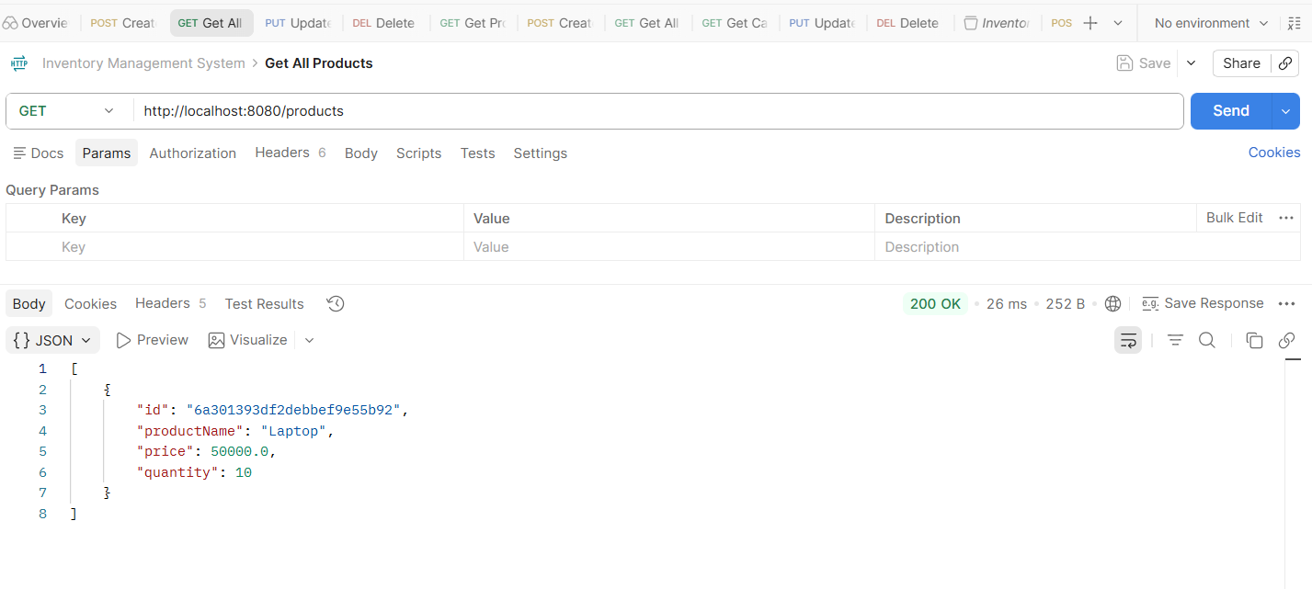
All products retrieved using get operation.
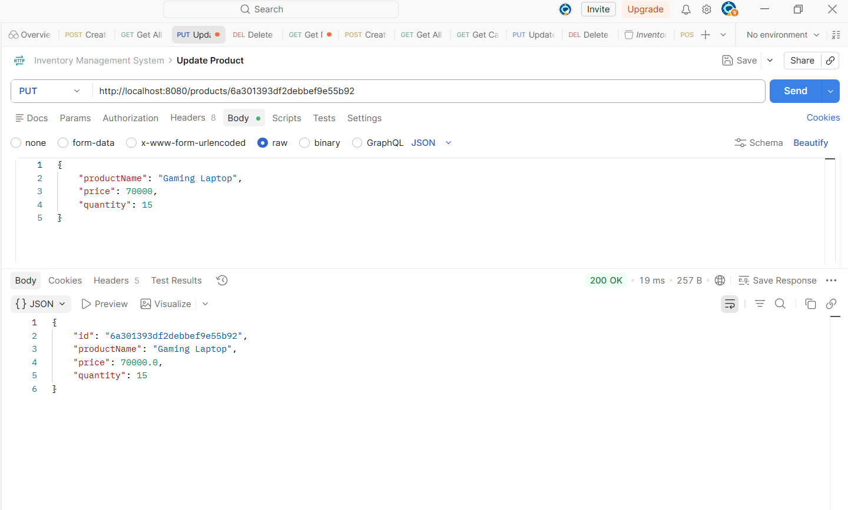
It demonstrates the Update Product operation, where the product details are modified to Gaming Laptop with a price of ₹70,000 and quantity 15.

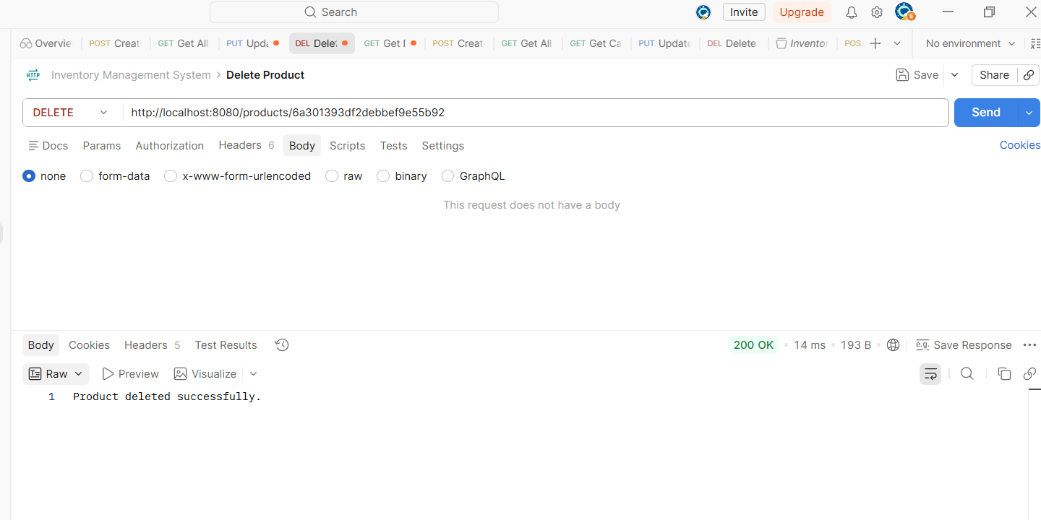
Product being deleted using product id

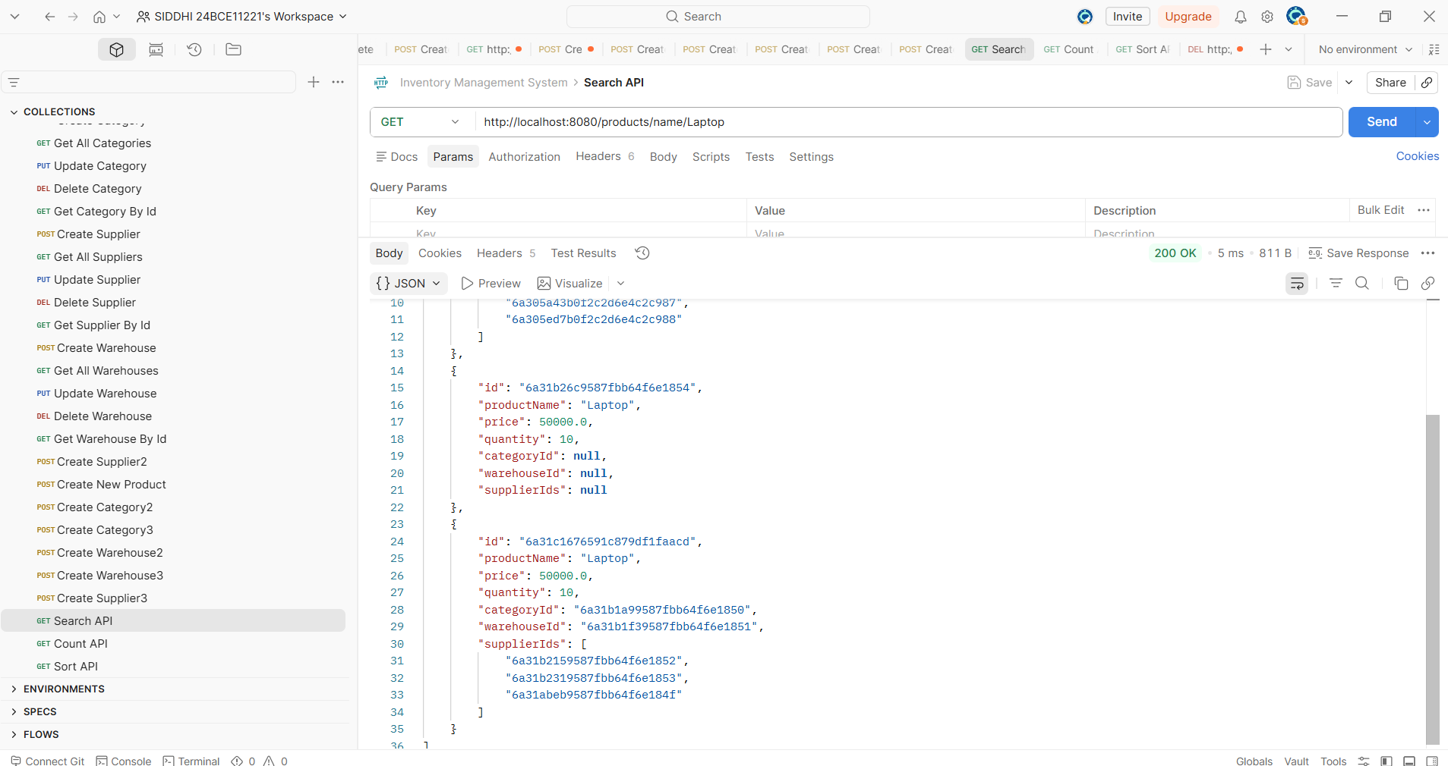
the Search API is functioning correctly, retrieving all product records with the name Laptop from MongoDB.

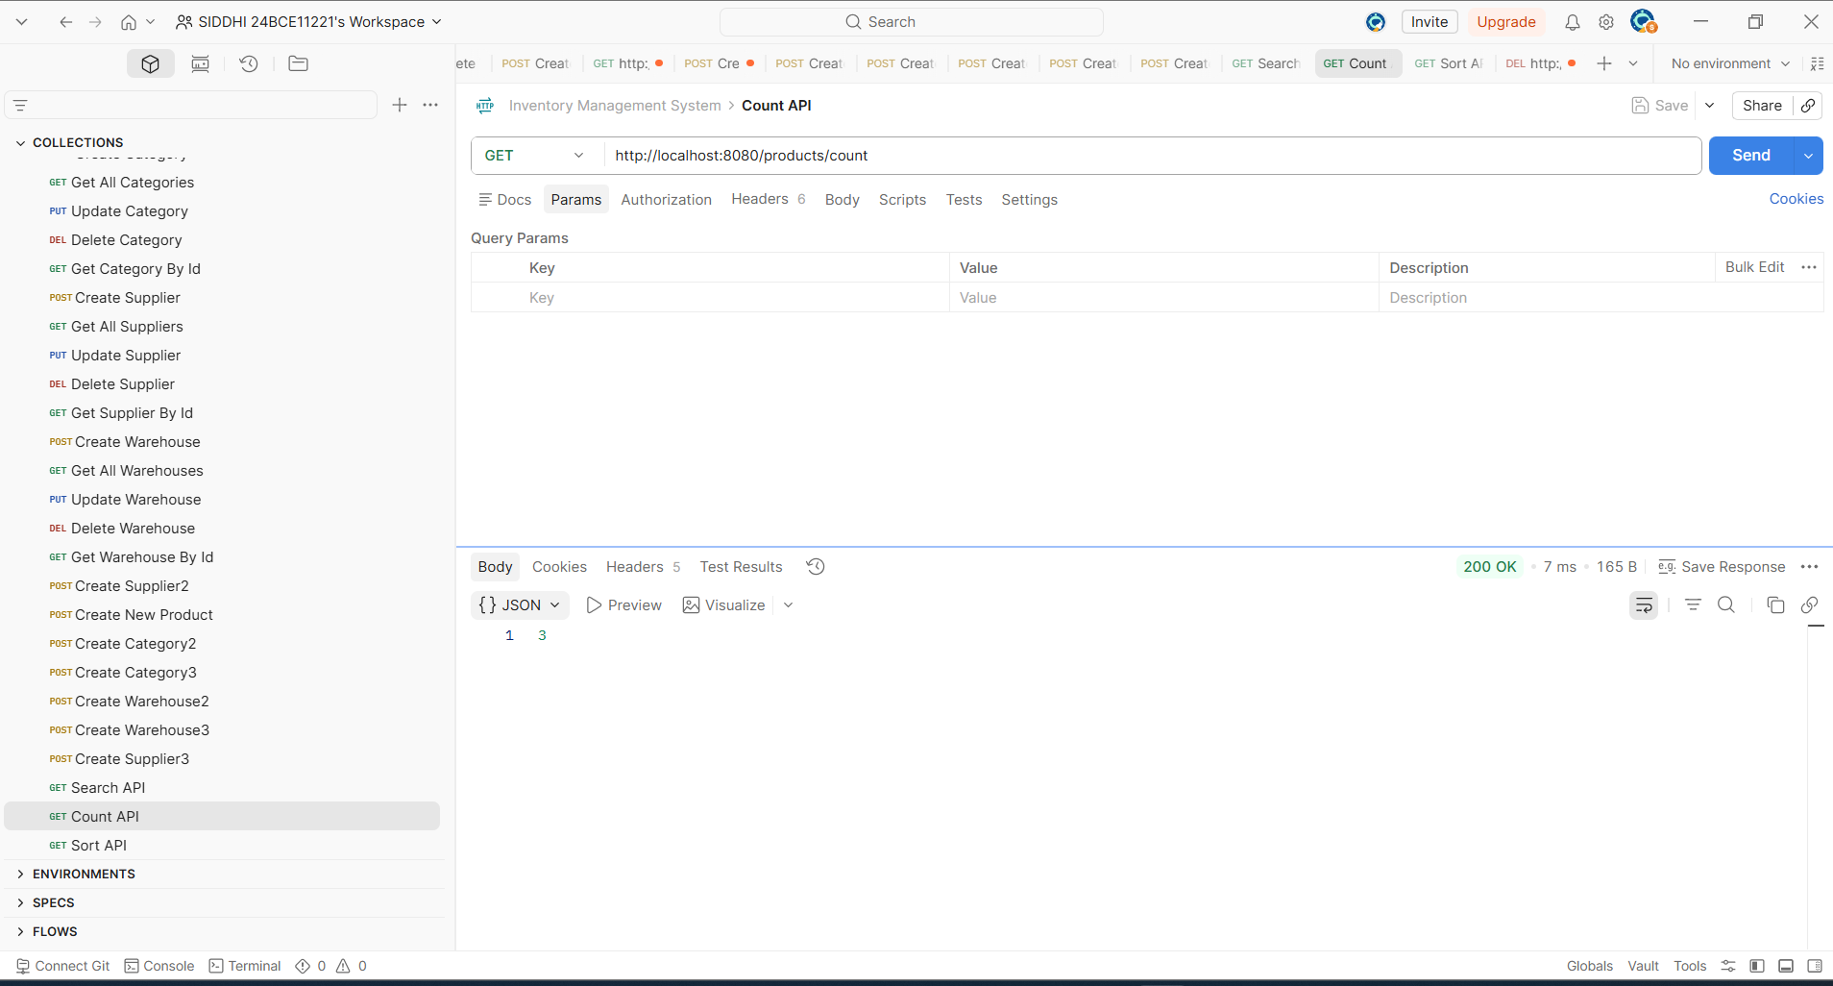
No. of products being counted using count api.

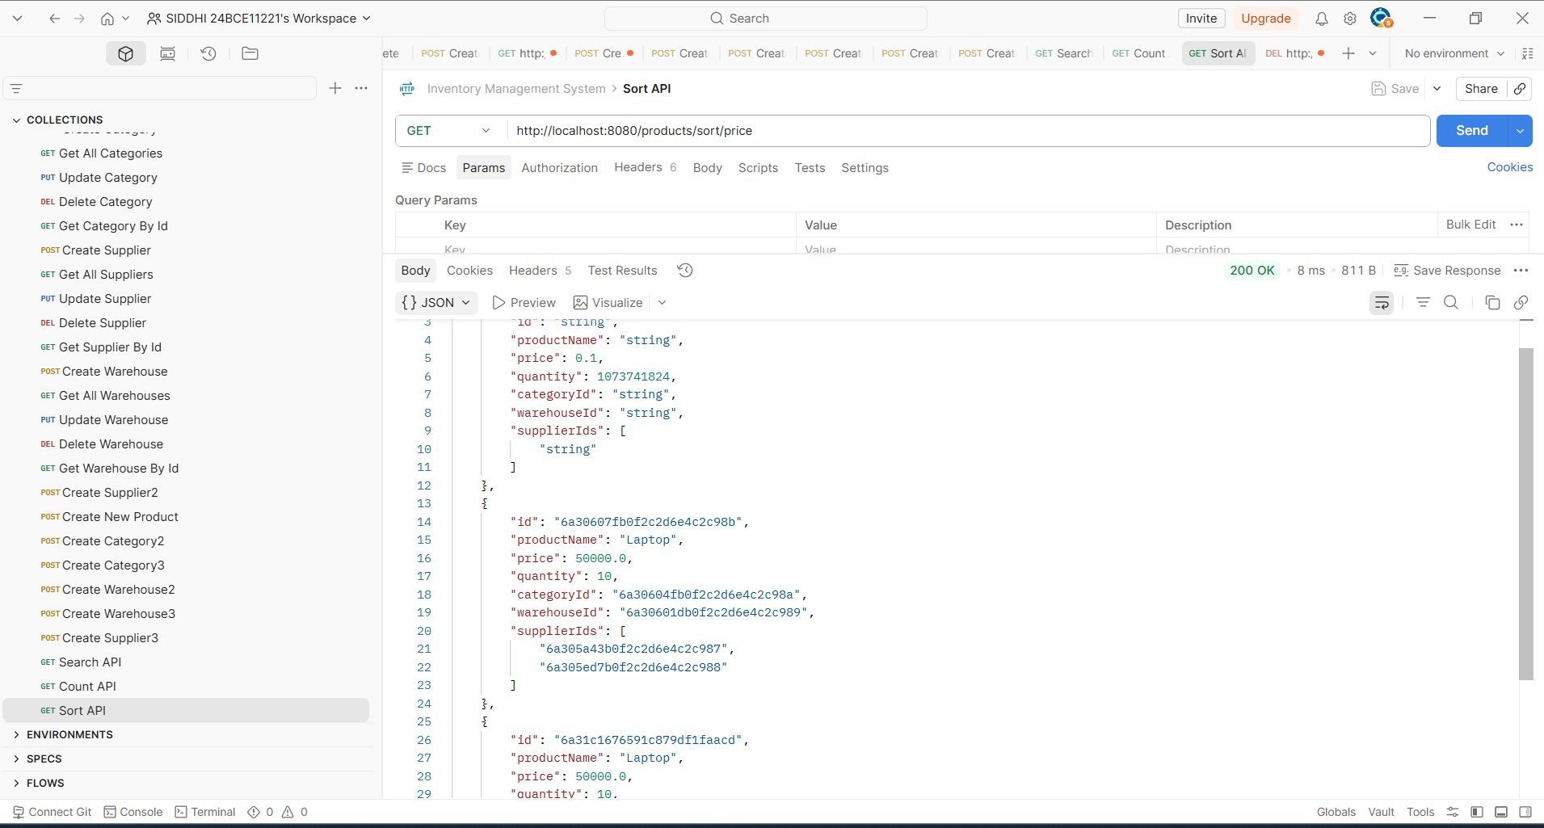
Price of different products is being sorted using sort api.

- Product Validation Error Handling

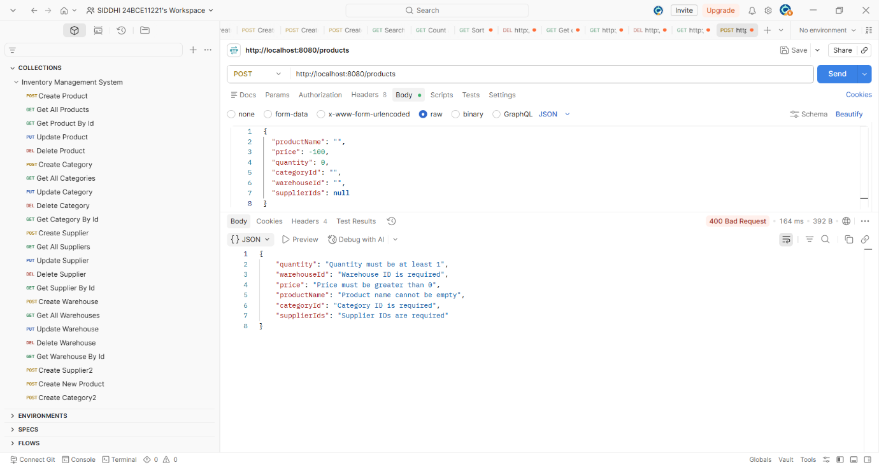

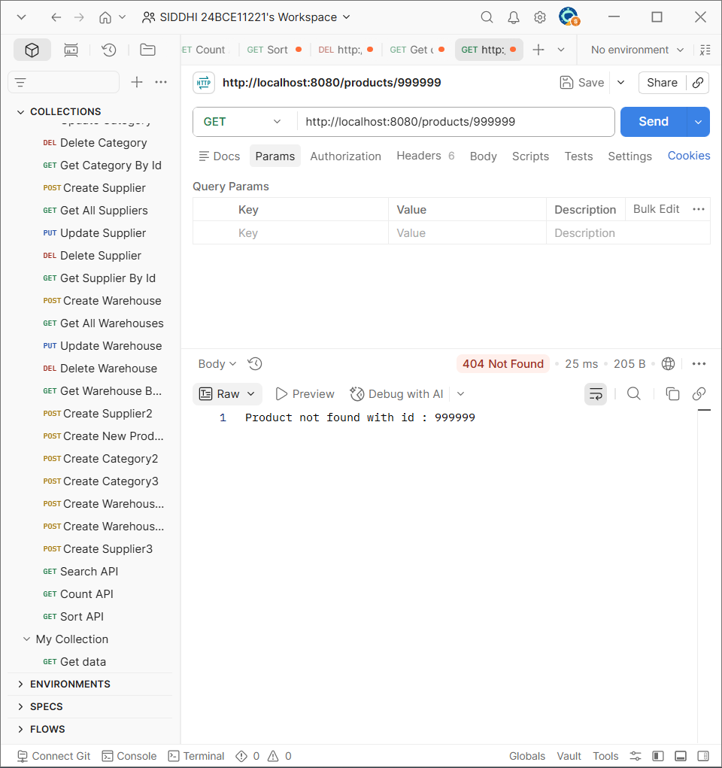
Demonstrates exception handling where given id ‘999999’ is not found
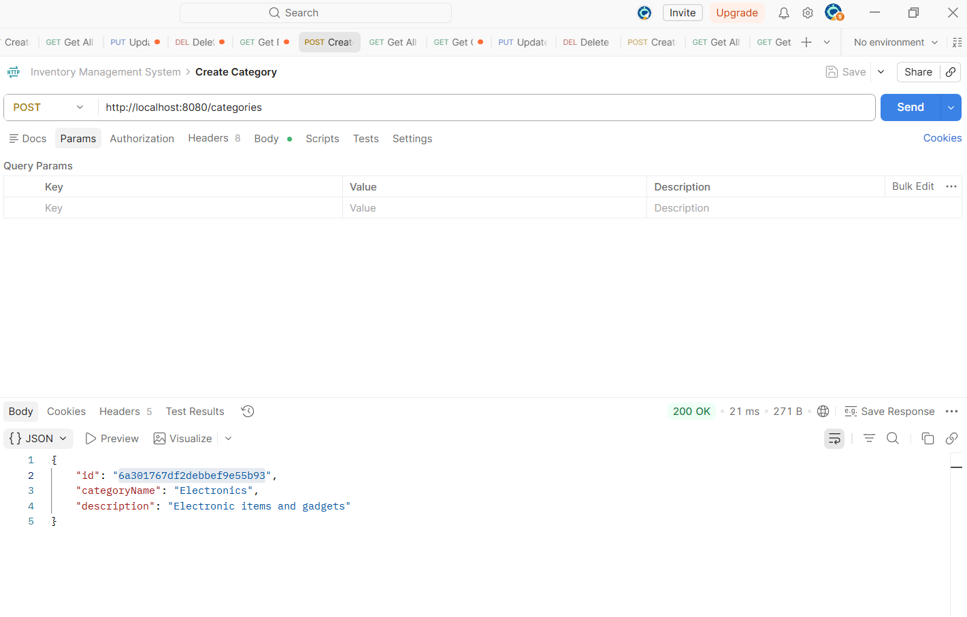
It demonstrates the Create Category operation, where a new category named Electronics with the description Electronic items and gadgets is successfully added.

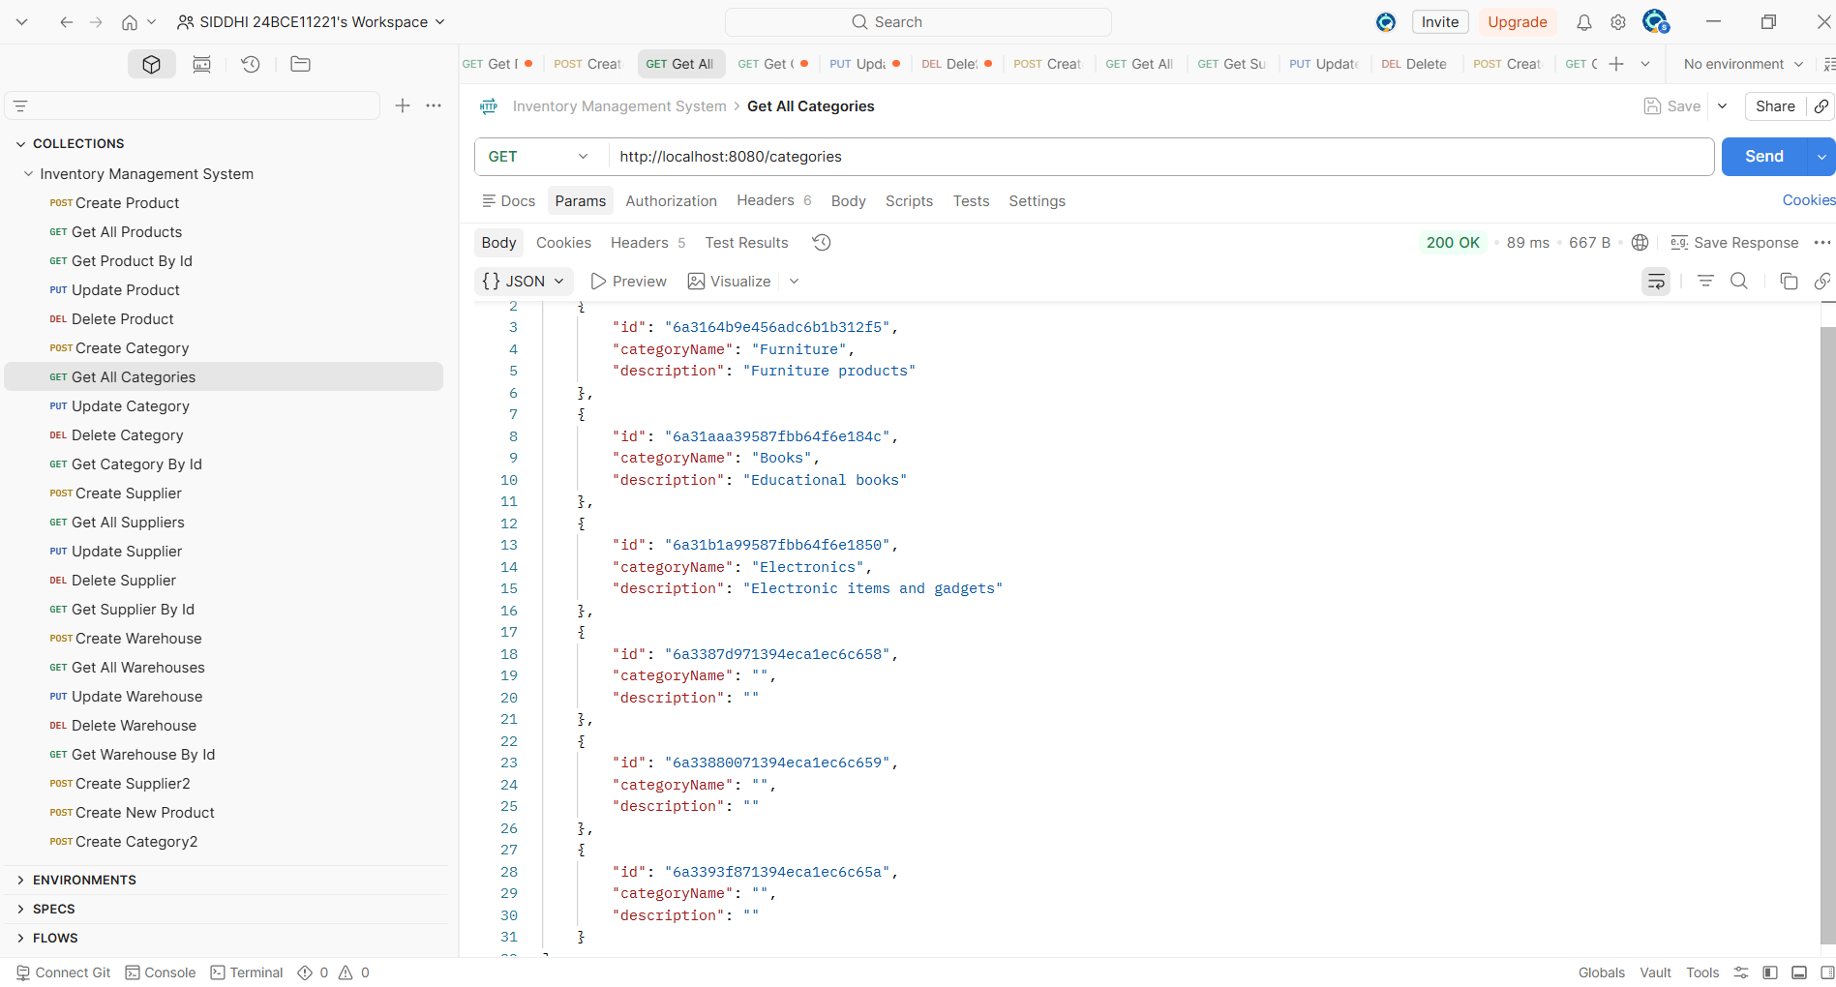
The 200 OK response confirms successful retrieval of category data from MongoDB. The JSON output lists categories such as Furniture, Books, and Electronics along with their descriptions
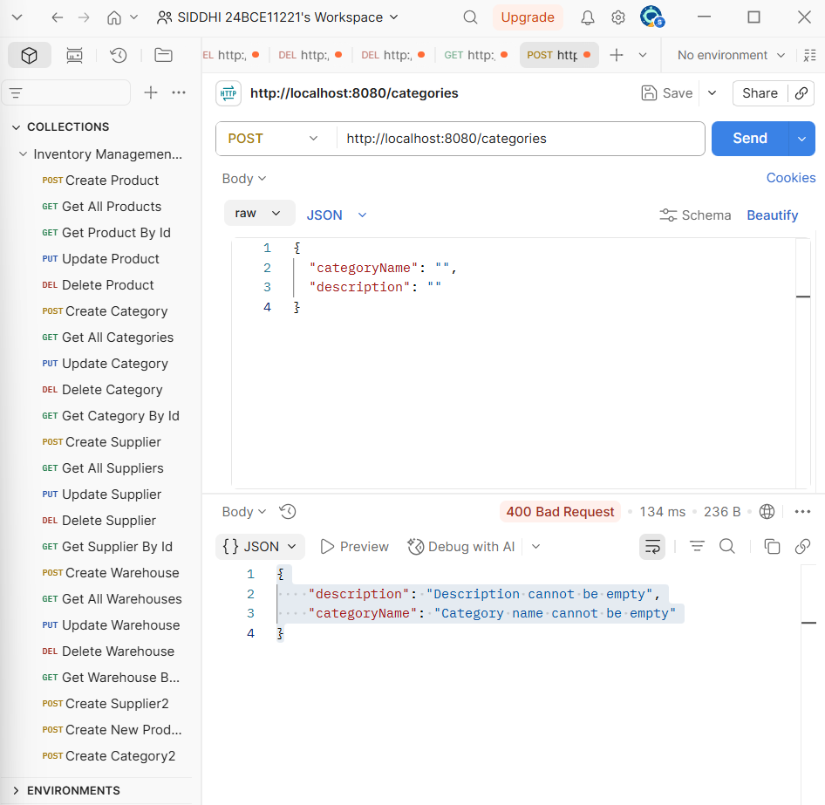
The JSON error message — “Category name cannot be empty” and “Description cannot be empty” — confirms that Spring Boot validation is properly implemented, ensuring required fields are not left blank when creating a new category.
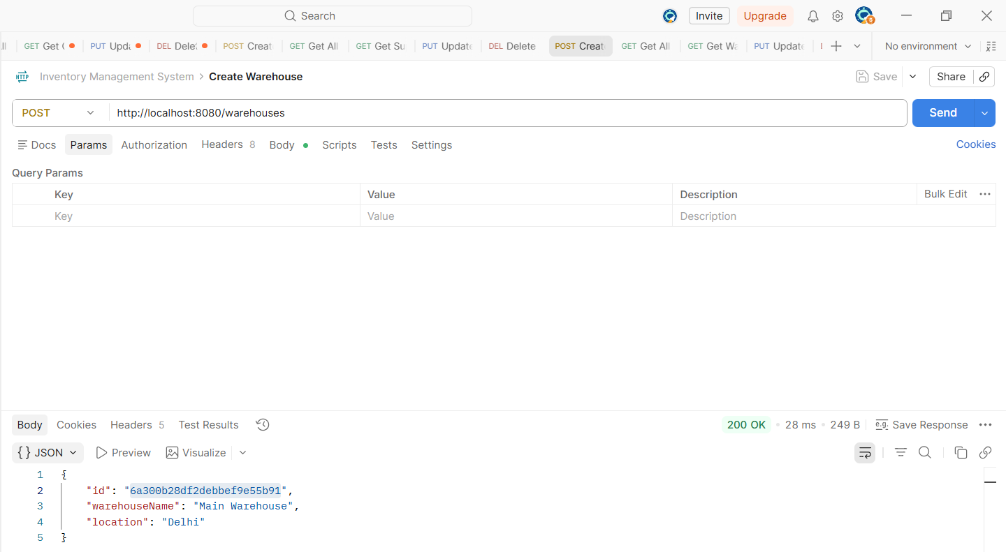
The 200 OK response confirms that the API executed correctly and the data - Main Warehouse located in Delhi was stored in MongoDB, validating the functionality of the Warehouse module
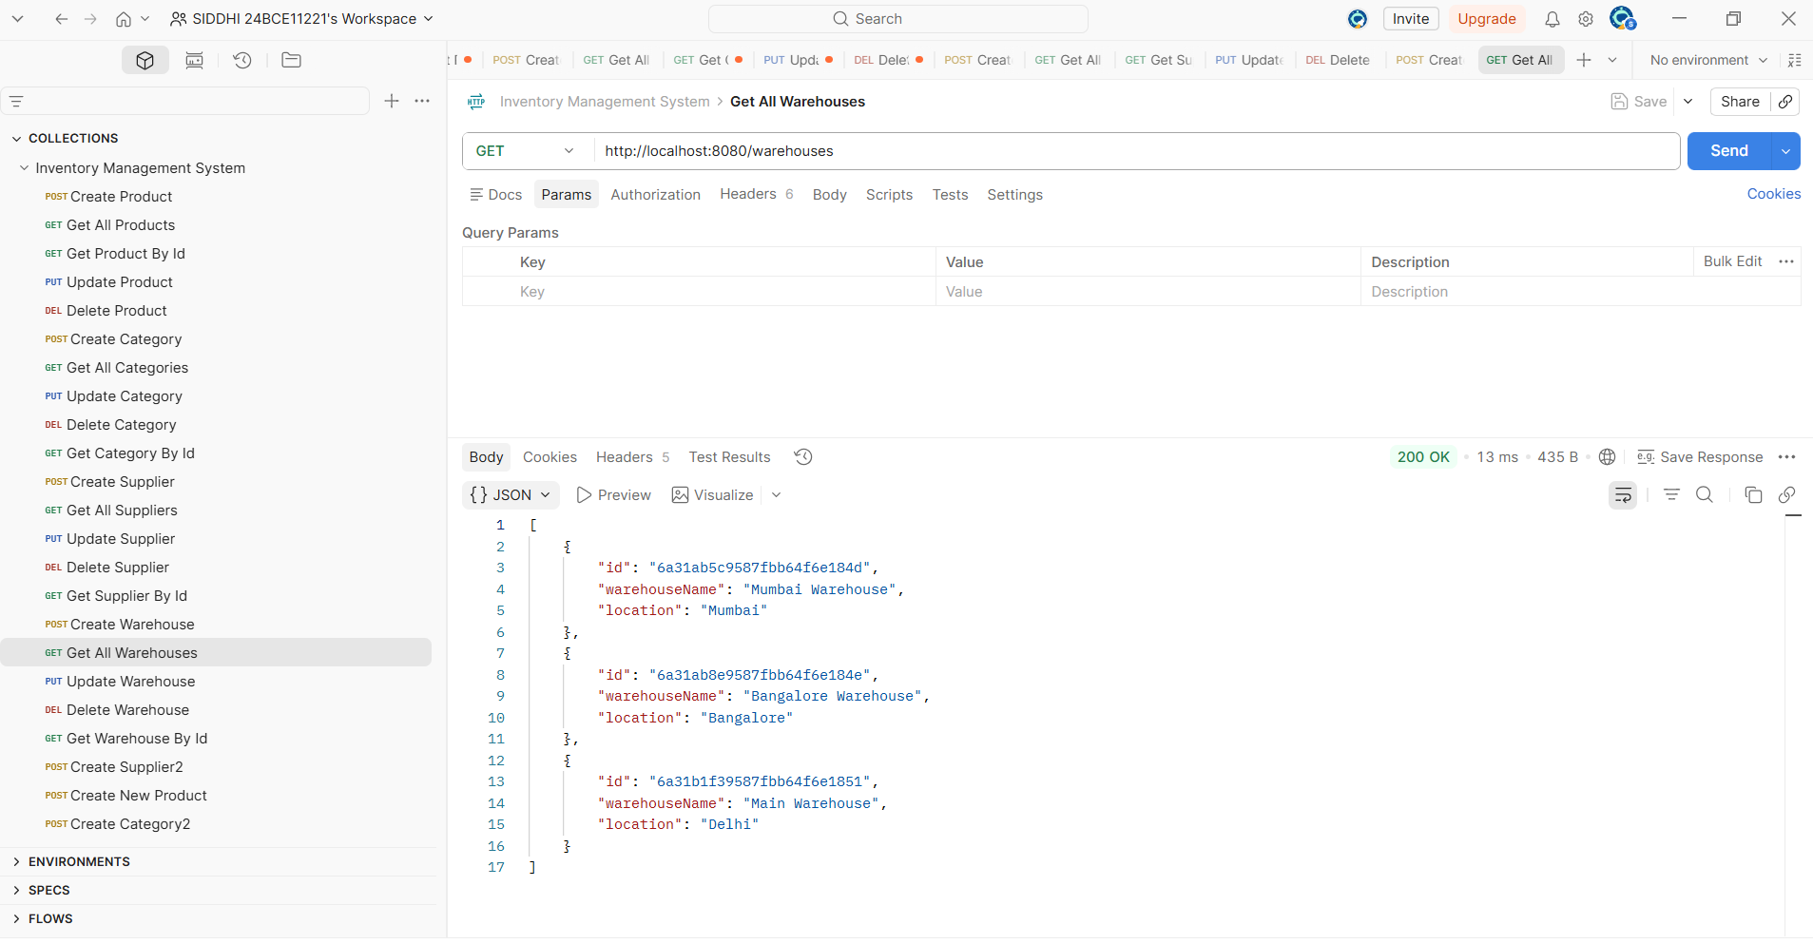
The response displays a 200 OK status, confirming successful retrieval of warehouse data from MongoDB. The JSON output lists multiple warehouses — Mumbai Warehouse, Bangalore Warehouse, and Main Warehouse along with their respective locations
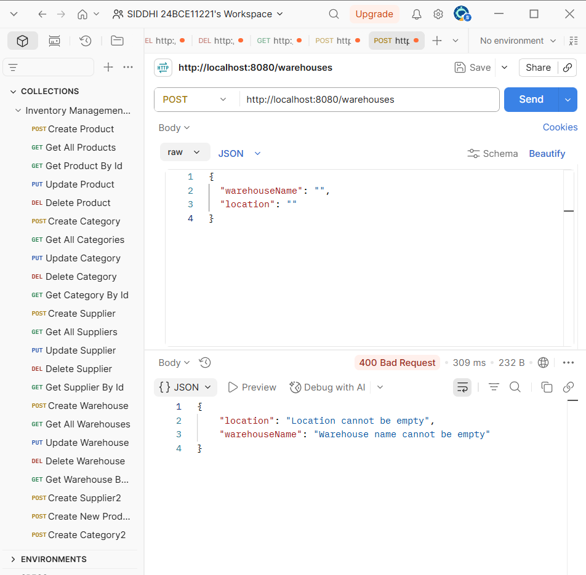
It demonstrates that input validation is correctly implemented in your Spring Boot application, ensuring mandatory fields are not left blank.
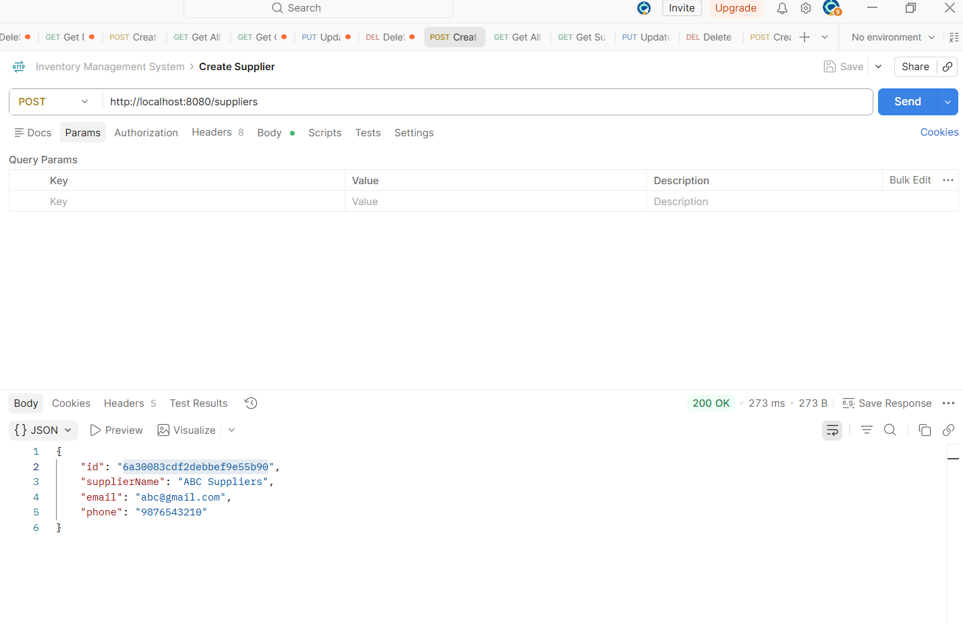
It demonstrates the Create Supplier operation, where a new supplier named ABC Suppliers is added successfully. The 200 OK response confirms that the API and MongoDB integration are working correctly, returning the supplier’s ID, name, email, and phone number in JSON format.

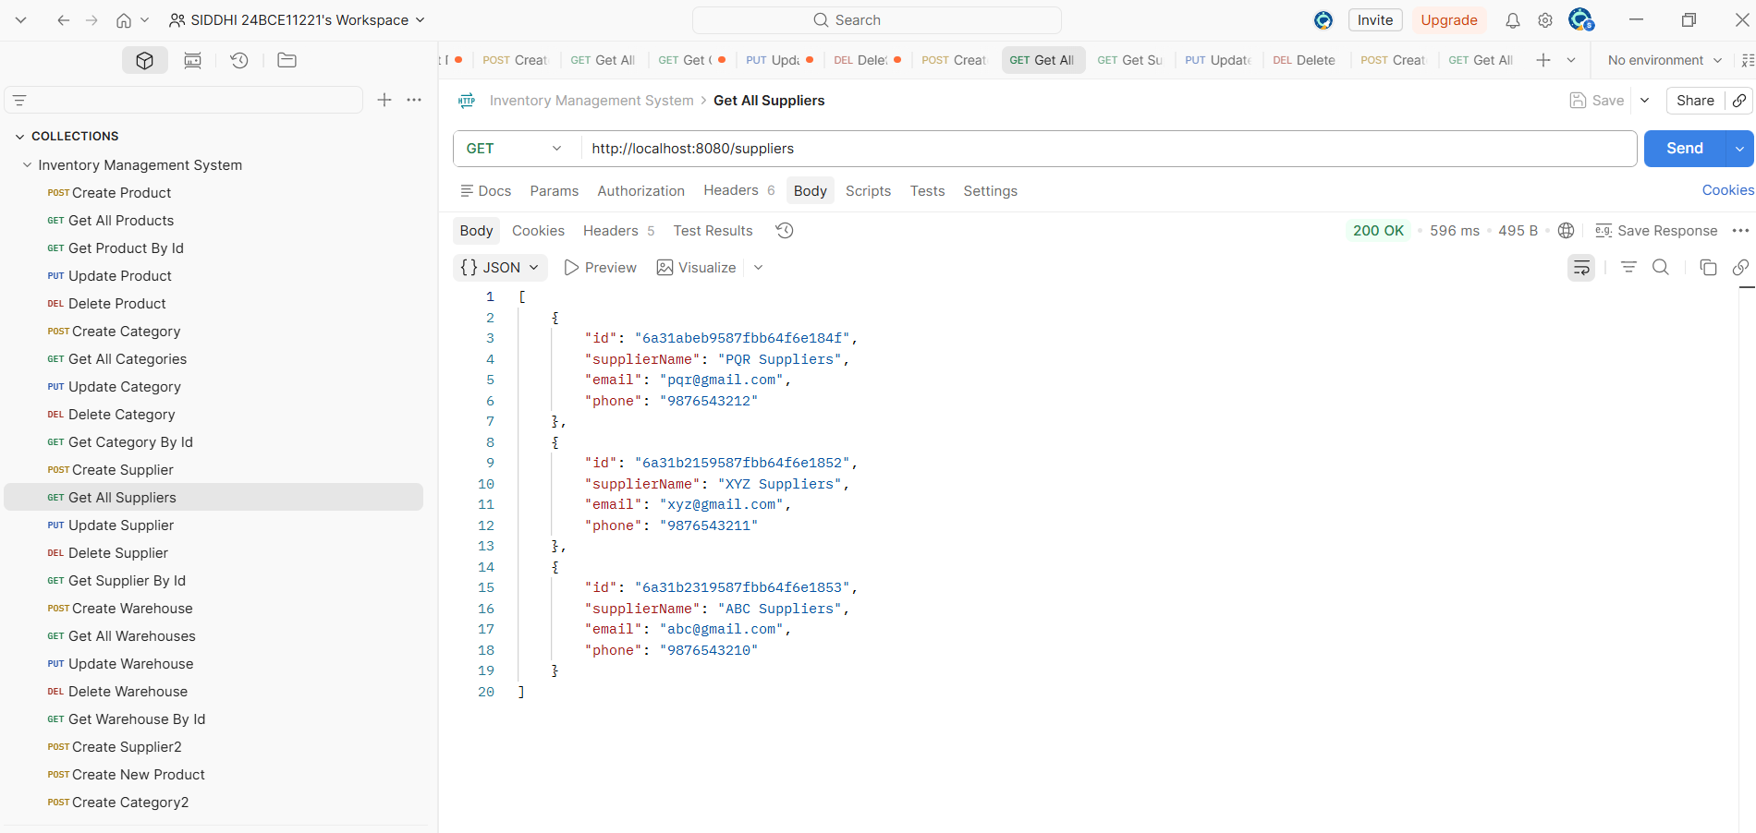
The response displays a 200 OK status, confirming successful retrieval of supplier data from MongoDB.

- Supplier Validation Error Handling

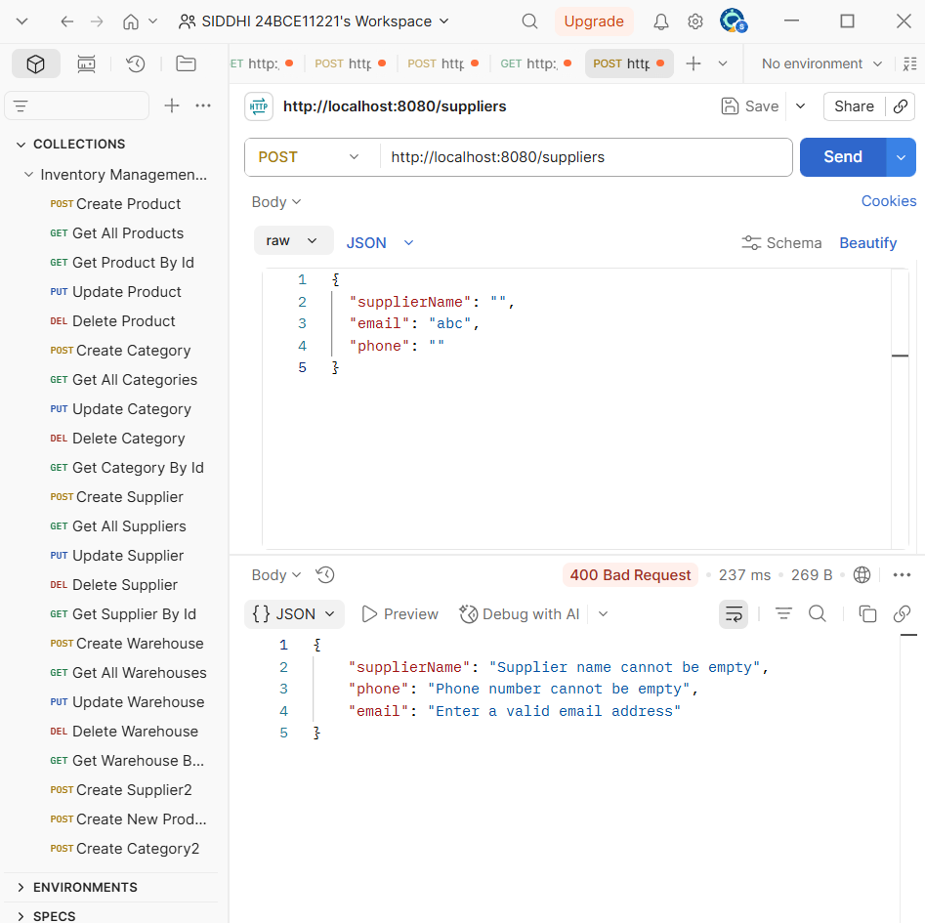

- API Documentation
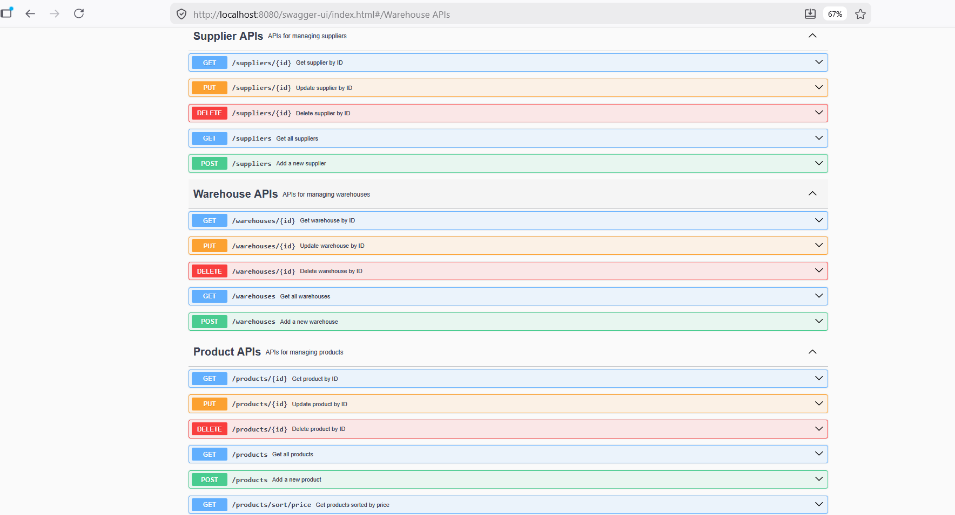
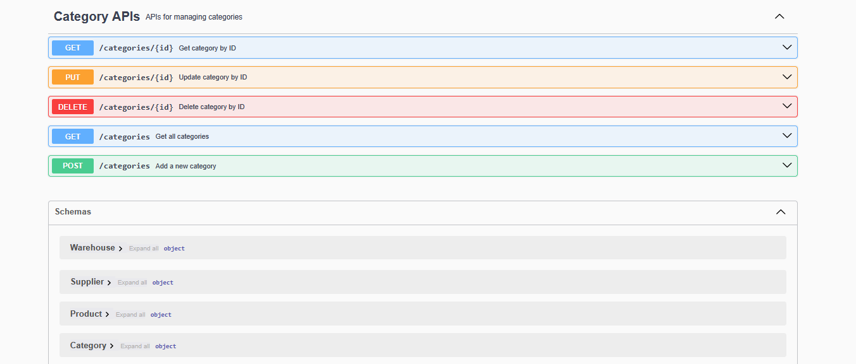
This screenshot shows the Swagger UI for your Inventory Management System. It lists all REST endpoints for Supplier, Warehouse,Category and Product modules, each supporting CRUD operations (GET, POST, PUT, DELETE). The interface confirms successful integration of Spring Boot with Swagger/OpenAPI, enabling interactive API testing and documentation directly from the browser.

- Outcome:
The system provides:
- Efficient inventory record management.
- Scalable backend architecture.
- Demonstration of industry-standard backend practices.
- Clear API documentation and testing evidence.
- Academic and practical relevance.

- Summary & Conclusion:
This project successfully integrates Spring Boot with MongoDB to build a backend inventory management system. It covers all major backend concepts: CRUD APIs, validation, exception handling, layered architecture, database relationships, API testing, and documentation.
By including multiple modules and entity relationships, the project demonstrates real-world inventory management scenarios. The use of Postman, Swagger, and GitHub ensures professional testing, documentation, and submission.

